**Master Functional Document**

|  |  |
| --- | --- |
| **Application** | NGERP - Centra |
| **Service Bundle** | Master Management |
| **Service Request** | Group Credit Limit |

**Description :**

Group Credit Limit master is used to group partner by to a credit limit. This is done with the help of contract no.

**Workflow Process :**

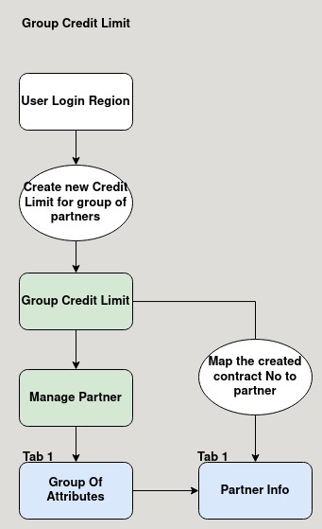

**Business Rules :**

* User should login as region to create a credit limit group.
* Create a contract number with the credit limit.
* Contract number can be mapped with AR trade partner in the partner info tab.
* Contract number can be mapped with multiple AR trade partner.
* When any one partner sales order is above credit limit, the credit limit error will show for all other partner.